# WasteXero Project

BK-IP2 project team

The project will be carried out in a way that is updated on a generation-by-generation basis.

This project including three main part: hardware development, imagine processing and Neural Network development.

### Hardware:

The hardware mainly completes the task of accurately capturing photos and sending them to the PC in time.

The hardware development part is based on the Raspberry Pi 3+, associated with many kinds of sensors, including camera, LED fill light, scaler.

First generation:

**Hardware composition**: Only one camera.

**Communication**: WIFI + Web page.

In this generation of products, we need to be able to capture photos from the trash bin can through a single camera and upload them to the web via WIFI. Then photo could be downloaded by PC.

Second generation

**Hardware composition:** one camera, **one scaler sensor**.

**Communication:** WIFI + Web page

In this generation, we will add a scale to get the weight of the garbage. In addition, we plan to **update the Web page**, so that the PC could get pictures from the Web page automatically if updating happened on Web page.

Third generation

**Hardware compositon: 2 or more cameras** with one scaler sensor.

Communication: WIFI + **server**.

In this generation, we plan to add more than one cameras to get more captures once from different directions and positions. In addition, we try to transfer images in a more efficient and more compatible way from Raspberry PI to PI or Cloud.

### Image processing

The image processing is mainly based on OpenCV in python. At the beginning, image processing is not compulsory. Because neutral network also could finish this part by training networks with more data. But image processing could play a huge role in the project with more than one camera or more than one garbage in the bin at the same times.

First generation:

The image background is removed by image segmentation, which reduces the pressure on the image recognition by the neural network.

Second generation

The second generation of products can separate multiple objects in one picture and store them separately.

Third generation

This generation of products can combine multiple photos captured from the same object into one picture. In this part overlapping would be the main problem.

### Neutral Network

The Neutral Network mainly based on TensorFlow and Keras in python. The neural network is responsible for giving accurate classification results to the processed pictures.

In theory, the more complex the neural network, the more complicated the tasks it can achieve, and the better the classification effect. But at the same time, the cost of training will be more expensive. As a result, we plan to build our Neutral Networks from simple to complex.

First generation

Building Neutral Network with Keras layer. ( i.e. Dense, drop, flat etc.). Compared with other method, Keras has provided us with a lot of layers of different structures. By choosing different kinds of layer, we can build the construction of the neural network by superimposing a relatively reasonable number of layers.

Second generation

Provide more customized functions to the neural network through the design of the custom layer

In this part, we could use the *session* in TensorFlow to build our custom layers, so that the network has more flexibility.

Finally, the purpose of strengthening the neural network is achieved through the mixed use of the custom layer and the Keras layer.

Third generation

The addition of existing excellent models will greatly enhance the neural network's performance. We can make a qualitative leap in the function of the neural network by mixing the previously built hybrid neural network with the excellent model.

The structure of some typical neural networks has been experimentally proven to have an excellent classification effect on pictures. These neural network models are also used in various industries and fields through successive retraining. The classified function of these neural network models can hardly be realized by personal construction in a short time. So, we can add these structures to our neural network to act as a layer, which greatly improves the performance of our neural network.

Fourth generation

Introducing an industrial-grade neural network model to enhance our neural network. ***InceptionV3*** model is one of them. But this part means extremely expensive training cost. From the paper, we believe that the accuracy of this scale of neural network can reach 98% or even higher.

## Appendix

### Raspberry PI:

<https://static.raspberrypi.org/files/product-briefs/Raspberry-Pi-Model-Bplus-Product-Brief.pdf>

<https://www.raspberrypi.org/documentation/hardware/computemodule/datasheets/rpi_DATA_CM3plus_1p0.pdf>

<https://components101.com/microcontrollers/raspberry-pi-3-pinout-features-datasheet>

Technical Specification:

Broadcom BCM2837 64bit ARMv7 Quad Core Processor powered Single Board Computer running at 1.2GHz

1GB RAM

BCM43143 WiFi on board

Bluetooth Low Energy (BLE) on board

40pin extended GPIO

4 x USB 2 ports

4 pole Stereo output and Composite video port

Full size HDMI

CSI camera port for connecting the Raspberry Pi camera

DSI display port for connecting the Raspberry Pi touch screen display

Micro SD port for loading your operating system and storing data

Upgraded switched Micro USB power source (now supports up to 2.4 Amps)

Expected to have the same form factor has the Pi 2 Model B, however the LEDs will change position

### Camera:

CSI camera:

<https://www.google.com/search?q=CSI+camera&rlz=1C1SQJL_zh-CNAU779AU779&oq=CSI+camera&aqs=chrome..69i57j0l5.5888j0j7&sourceid=chrome&ie=UTF-8>

install: <https://linux.cn/article-3650-1.html>

<https://www.cnblogs.com/uestc-mm/p/7587783.html>

<https://blog.csdn.net/Meteor_s/article/details/81037959>

<https://www.rs-online.com/designspark/chi-pi-cam-setup-tutorial>

**weight sensor:**

HX711 ADC GPIO breadboard

<https://tutorials-raspberrypi.com/digital-raspberry-pi-scale-weight-sensor-hx711/>

### light:

some simple LED GPIO breadboard

<https://cn.popularhowto.com/building-raspberry-pi-led-flasher>

### interface extension:

<https://www.google.com/search?rlz=1C1SQJL_zh-CNAU779AU779&q=raspberry+pi3b%2B+extension+board&spell=1&sa=X&ved=0ahUKEwjv0pHBj5DkAhVQWisKHUqcAr8QBQgsKAA&biw=1280&bih=578>

<https://blog.csdn.net/bona020/article/details/78643734>

### connect wifi:

<https://blog.csdn.net/hktkfly6/article/details/73302648>

<https://zhuanlan.zhihu.com/p/32288573>

<https://tbfungeek.github.io/2016/03/11/%E4%BD%BF%E7%94%A8ssh%E5%9C%A8%E6%A0%91%E8%8E%93%E6%B4%BE%E5%92%8C%E4%B8%BB%E6%9C%BA%E9%97%B4%E6%8B%B7%E8%B4%9D%E6%96%87%E4%BB%B6%E5%92%8C%E6%96%87%E4%BB%B6%E5%A4%B9/>

<https://blog.csdn.net/baidu_34045013/article/details/52123225>

<https://blog.csdn.net/u010900754/article/details/53048604>

### GPIO:

<https://www.ccarea.cn/archives/215>

### Neutral Networks

Our neutral Networks already could achieve below result:

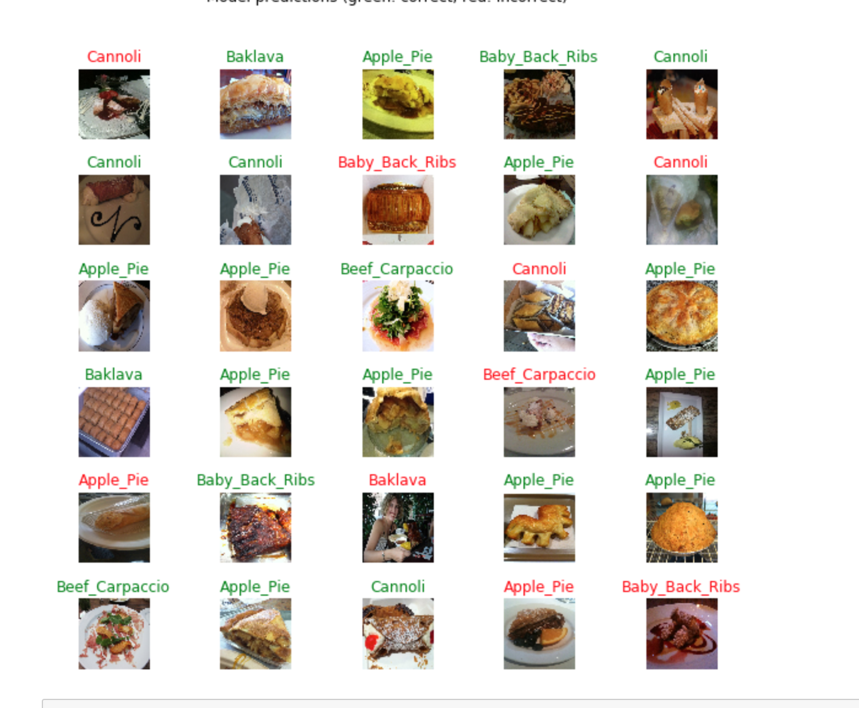

The green name means the result is right, red name mean prediction is wrong.